|  |  |
| --- | --- |
| C:\Users\n0313175\AppData\Local\Microsoft\Windows\INetCache\Content.Word\LMI_Safeco_logo_CMYK_New_Brand.jpgImage result for havas helia logo | **How to Customize URLs within the Employer Email Templates** |

Once you download your email template(s), **you must change the destination URL of the button(s) prior to sending to your recipient list.** Part A below outlines how to do this within your OFT file on an individual email basis, while Part B will show you how you can do this one time to your core OFT file and then reuse that file throughout the year.

**PART A: ALTERING THE URL OF ONE OFT TEMPLATE**

1. Open the OFT file within Outlook so that it creates a new email message.
2. Within the email, hover over the “Get your quote” CTA button. **NOTE: Do not click the button**. This will edit the text inside the button rather than the link itself.
3. Right click and choose “Edit Link”

1. In the dialog box that appears, enter your company’s custom URL in the box near the bottom labeled “Address,” replacing whatever URL already exists. You must enter the full URL, including https:// at the beginning.

* 1. **Note*:*** Your custom URL can be found in the “Email URL’s” link.

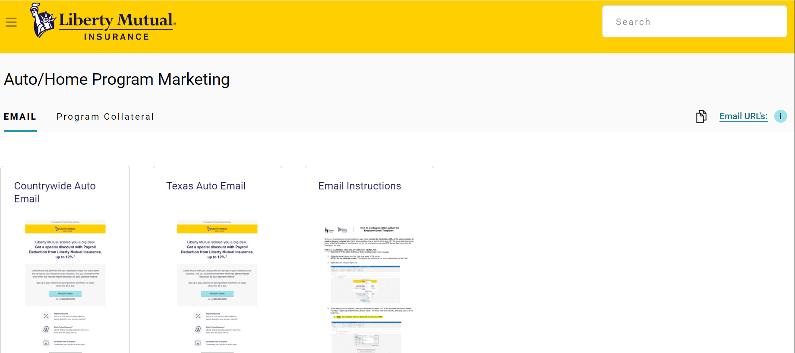

1. Hit “OK” to save the change.
2. Repeat steps 1-4 for any additional buttons that exist in the email.

**PART B: SAVING THE OFT FILE FOR FUTURE RE-USE**

1. Follow the steps above to alter the base OFT file.
2. After Steps 1-6 above are complete, go to “File” and “Save As.”
3. In the “Save as type” box, choose “Outlook Template.”
4. Save the file in a preferred location.

For your next email deployment, you will simply open the OFT file so that a new email message is created. All URL changes should be in-tact.